Software Versions for SA IFM Displays

Software Version 9.0
Will need to watch Display boot up, on IFM loading screen you will need to see 2.0.7.0
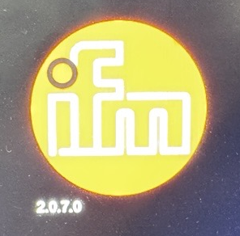

Software Version 8.9.23
Will need to watch Display boot up, on IFM loading screen you will need to see 2.0.2.2
